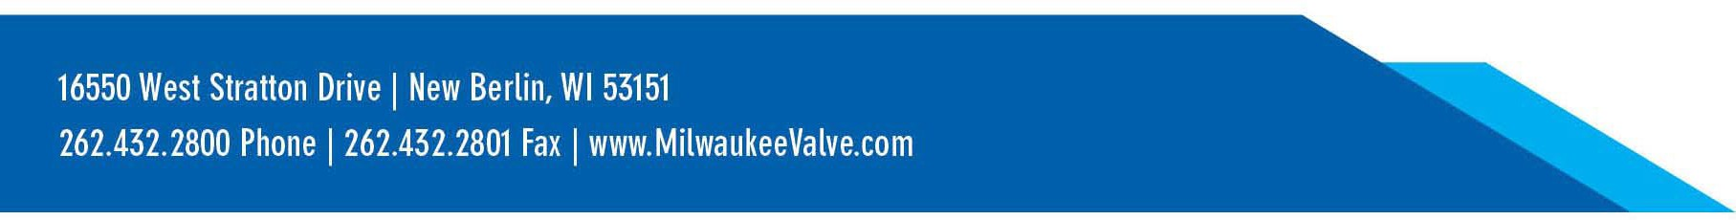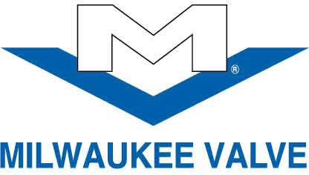

4/11/2025

To: All Milwaukee Valve & Hammond Valve Distributors

Subject: Tariff and Market Related Price Increase

The White House clarified this week that the effective U.S. tariff rate on Chinese imports is now 125%, in addition to the original IEEPA tariffs of 20%. Other nations currently with a 90 day pause in escalation are now set at 10% across-the-board tariff. These are clearly unprecedented and dynamic market conditions.

As a result of these changes, we must increase prices accordingly. Effective Tuesday, April 15, 2025, Milwaukee Valve will be implementing a price increase on all new orders as listed below:

|  |  |  |
| --- | --- | --- |
| **Product Groups** | **List Price Increase** | **Effective** |
| Carbon & Stainless: High Performance Butterfly | 60.0% | 4/15/2025 |
| Brass: Ball, Press, Gate, Globe, Check, P&H | 60.0% | 4/15/2025 |
| Carbon & Stainless: Ball | 60.0% | 4/15/2025 |
| Iron: Butterfly "C" Series | 60.0% | 4/15/2025 |
| Iron: Gate, Globe, and Check “M” Series | 60.0% | 4/15/2025 |
| Cast Steel: Gate, Globe, and Check | 60.0% | 4/15/2025 |
| Iron: Butterfly “H” and "M" Series | 40.0% | 4/15/2025 |
| Iron: Gate, Globe, and Check " A" Series | 40.0% | 4/15/2025 |
| Bronze: Ball, Gate, Globe, and Check | 12.0% | 4/15/2025 |
| Bronze: Butterball and Slo Close | 12.0% | 4/15/2025 |
| Commercial Products: Other | 12.0% | 4/15/2025 |

The percentage of increase by product group shown above will apply to both list pricing and all special net pricing. The new list pricing will be available on the Milwaukee Valve and Hammond Valve websites.

Due to the abrupt impact of these changes, we are unable to delay implementation. The factors influencing this price increase are evolving and subject to further change.

We trust you can understand our need to recover these costs and thank you for your continued interest and support of our products.

Sincerely,

MILWAUKEE VALVE COMPANY, LLC

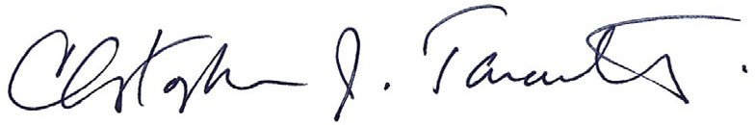

Christopher J. Tarantello

Vice President Sales & Marketing – Commercial & Industrial